Assignment 7:

Write a C program that includes a user-defined function named binarySearch with the signature int binarySearch(int arr[], int size, int target);. The function should perform a binary search on a sorted array of integers and return the index of the target element if found, and -1 otherwise.

Source Code:

#include<stdio.h>
int binarySearch(int arr[], int size, int target) {
int low = 0, mid, high = size-1;
while (low<=high) {
mid = (low+high)/2;
if (arr[mid]==target)
return mid;
else if (target<arr[mid])
high = mid-1;
else
low = mid+1;
}
return -1;
}
int main() {
int i, arr[10], n, target, result;
printf("Enter the size of the Array : ");
scanf("%d",&n);
printf("Enter the Elements of the sorted array in ascending order : ");
for (i=0;i<n;i++)
scanf("%d",&arr[i]);
printf("Enter the target element : ");
scanf("%d",&target);
result = binarySearch(arr,n,target);
if (result==-1)
printf("The targeted element is not found.");
else
printf("The targeted element is at index : %d",result);
return 0;
}

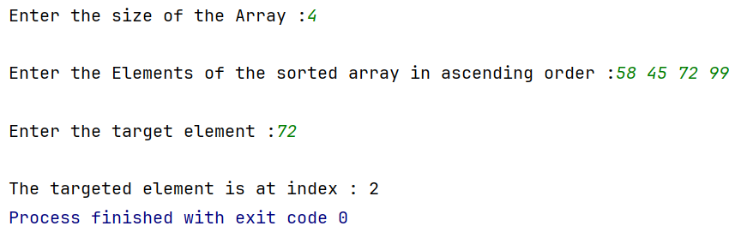
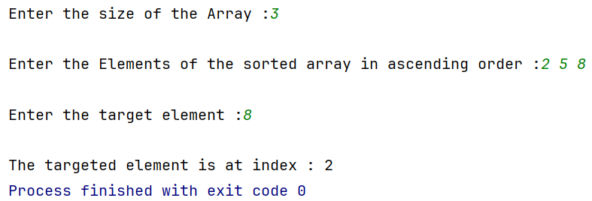
Output:

